CSE 206 (Digital Logic Design Sessional)

Experiment No.: 07

Name of the Experiment:

**Flip-Flops and Registers**

|  |  |
| --- | --- |
| Group No.: | 06 |
| Writers’ Roll: | 1805117  1805118 |
| Section: | B2 |
| Department: | CSE |
| Other Group Members: | 1805116  1805119  1805120  1705107 |
| Date of Submission: | 12/06/2021 |

**Problem 1.**

Problem specification:

Design and implement a master-slave JK flip-flop using only NAND gates.

Excitation Table:

|  |  |  |  |  |  |  |
| --- | --- | --- | --- | --- | --- | --- |
| PRESET | CLEAR | J | K | CLK | Qn+1 | Mode |
| 0 | 0 | X | X | X | Not allowed | Not allowed |
| 0 | 1 | X | X | X | 1 | Set |
| 1 | 0 | X | X | X | 0 | clear |
| 1 | 1 | X | X | 0 | Qn | Hold |
| 1 | 1 | 0 | 0 | 1 | Qn | Hold |
| 1 | 1 | 0 | 1 | 1 | 0 | Reset |
| 1 | 1 | 1 | 0 | 1 | 1 | Set |
| 1 | 1 | 1 | 1 | 1 | (Qn)’ | Toggle |

Required instruments:

|  |  |  |  |
| --- | --- | --- | --- |
| **No** | **Name** | **Model** | **Quantity** |
| 01 | Logisim Software |  |  |
| 02 | IC(Quad 2-Input NAND Gate) | 7400 | 5 |
| 05 | Wires |  |  |
| 06 | Input Pins |  | 2 |
| 07 | Output Pins |  | 2 |

Circuit diagram:

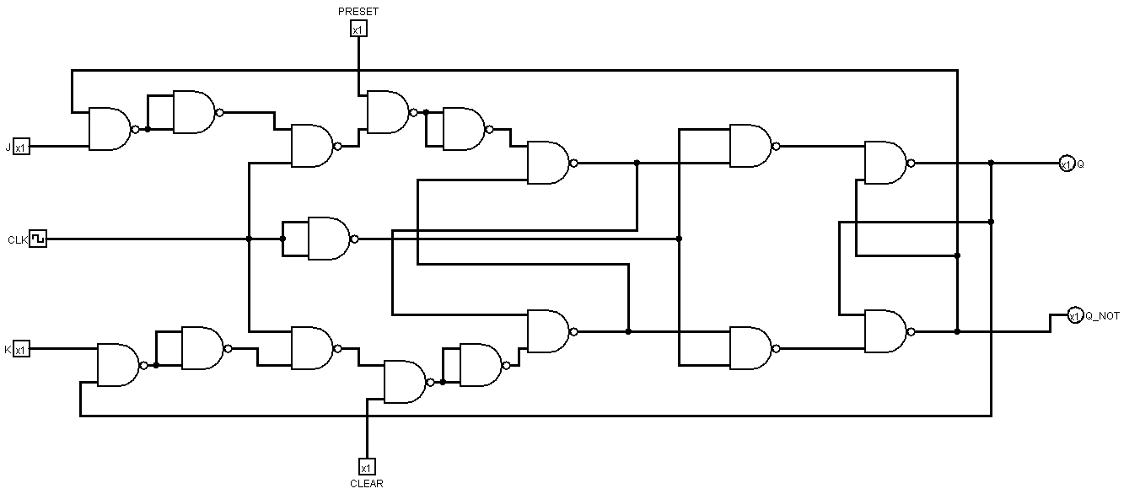

Observations:

1. Since Q and Q’ had no preset values at first, the connection was not duly established. Therefore, to solve this problem we have used Preset and Clear to give an initial value in the circuit.
2. The Master-slave paradigm solves the race around problem of a single J-K flip-flop.
3. We tried to make the circuit such a way that it was not too dense with wires.
4. We have used the documentations of the ICs to make sure the connections were given through the right pins.
5. We checked the output according to the excitation table.

**Problem No.2:**

Problem Specification:

Design and implement a 4-bit universal shift register.

Required Instruments:

|  |  |  |  |
| --- | --- | --- | --- |
| **No** | **Name** | **Model** | **Quantity** |
| 01 | Logisim Software |  |  |
| 03 | IC (Dual 4:1 MUX) | 74153 | 2 |
| 04 | IC (D-Flip flop) | 7474 | 2 |
| 05 | Wires |  |  |
| 06 | Input Pins |  | 8 |
| 07 | Output Pins |  | 4 |

Excitation Table:

|  |  |  |  |  |  |  |  |  |  |
| --- | --- | --- | --- | --- | --- | --- | --- | --- | --- |
| Input | | | | | Output | | | | |
| Clear | Clock | S1 | S0 | Internal Signal,  Di(i = 0, 1, 2, 3) | A3 | A2 | A1 | A0 | Mode |
| 0 | X | X | X | X | 0 | 0 | 0 | 0 | Asynchronous |
| 1 | X | 0 | 0 | X | A3 | A2 | A1 | A0 | Data Hold |
| 1 |  | 0 | 1 | Ai-1 | I0 | A3 | A2 | A1 | Shift Right |
| 1 |  | 1 | 0 | Ai+1 | A2 | A1 | A0 | I2 | Shift Left |
| 1 |  | 1 | 1 | Ai | I3 | I2 | I1 | I0 | Parallel Load |

Circuit Diagram:

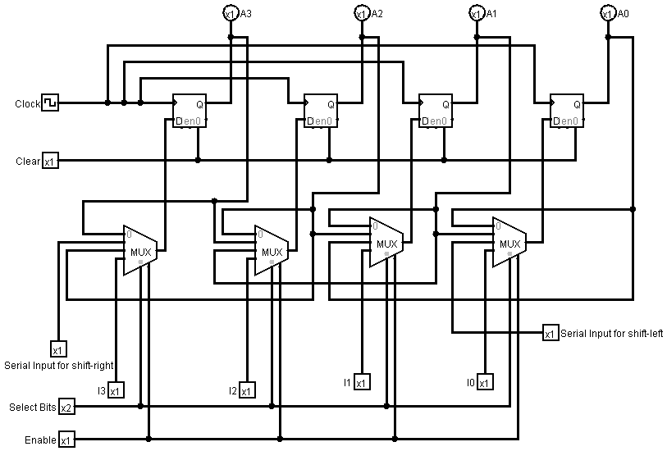

Observations:

1. We tried to make the circuit such a way that it was not too dense with wires. The combinational part of the circuit could alternately be built with a set of AND gates. We have avoided that method due the increased complexity in the circuit.
2. We have used the documentations of the ICs to make sure the connections were given through the right pins.
3. We checked the output according to the excitation table.